MAJOR PROJECT

**FAST FOOD**

**Submitted by Navpreet singh**

**Contents**

Project Proposal 2

Goals and Objectives 2

Scope and Deliverables 2

Project Scope 2

Project Deliverables 2

Project Specification and Target Audience 2

Project Schedule and milestones 3

Resources Required 3

Detailed Design 4

Home Page 4

Login Page 4

Admin Register car Page 5

Car enteries Page 6

Models Page 6

Project Testing 8

User Manual 8

User Activities 9

Admin Activities 9

# Project Proposal

## Goals and Objectives

The main objective of this project is to establish a new web application formed as “Fast Food Joint”. Moving further, two types of users are included in this website i.e Admin and user. Both have their own responsibility like admin can register,remove ,update and can check the details of food items. Moreover, admin can register a new item as well. Admin can also delete and check the details of customer as well as transactions of sales while users can login into website by having their own credentials and moreover, one can register himself/herself as a new user. User can see the items and purchase them.

## Scope and Deliverables

## Project Scope

The time taken for this project was approximately 21 days. The basically project is to implement an admin functionality as add,delete and update.Moreover, for users the purpose is to buy.

## Project Deliverables

To achieve the goal of our project, we have set the following deliverables:

|  |  |
| --- | --- |
| **Deliverables** | **Explanation** |
| Project Planning | Project planned included timing and data. |
| Design | Project planned well from starting and ending for well responsive. |
| Coding | All coding is included in project to work website functionality. |
| Implementation and Testing | In this project how the application is implemented and testing part is working. |
| Final Documentation | Final documentation is covered in this for project. |

## Project Specification and Target Audience

* For admin and user both login and logout page functionality should be worked well and should be secure.
* For admin add, update ,delete and details functions should be work.
* For users register form view items ,buy should be work properly.

Futhermore, the audience for this project is mainly food lover who can buy a good items for good health.

# Project Schedule and milestones

|  |  |  |
| --- | --- | --- |
| Phases | Time Frame in weeks | Information about project Completed |
| Project planning | 1 | * Discussion about project * Project explanantion * Analysis Report * Project Proposal impleented |
| Part1 | 2 | * Database designed * Both front and end of project designed |
| Part2 | 2-3 | * Implemetation at front of project * Implementation at back end of project * Final project |
| Part 3 | 3 | * Testing part analysis * Final report in the form of documentation and writing report |

# Resources Required

Following are the resources required to complete this project:

* ASP.Net MVC and Identity Framework
* Windows OS 10
* Minimum i5 processor with 8 GB of RAM
* MS Word, Excel

# Detailed Design

## Home Page

The main page of this project is Home page , which contains menu buttons and register and login button on the navigation bar.

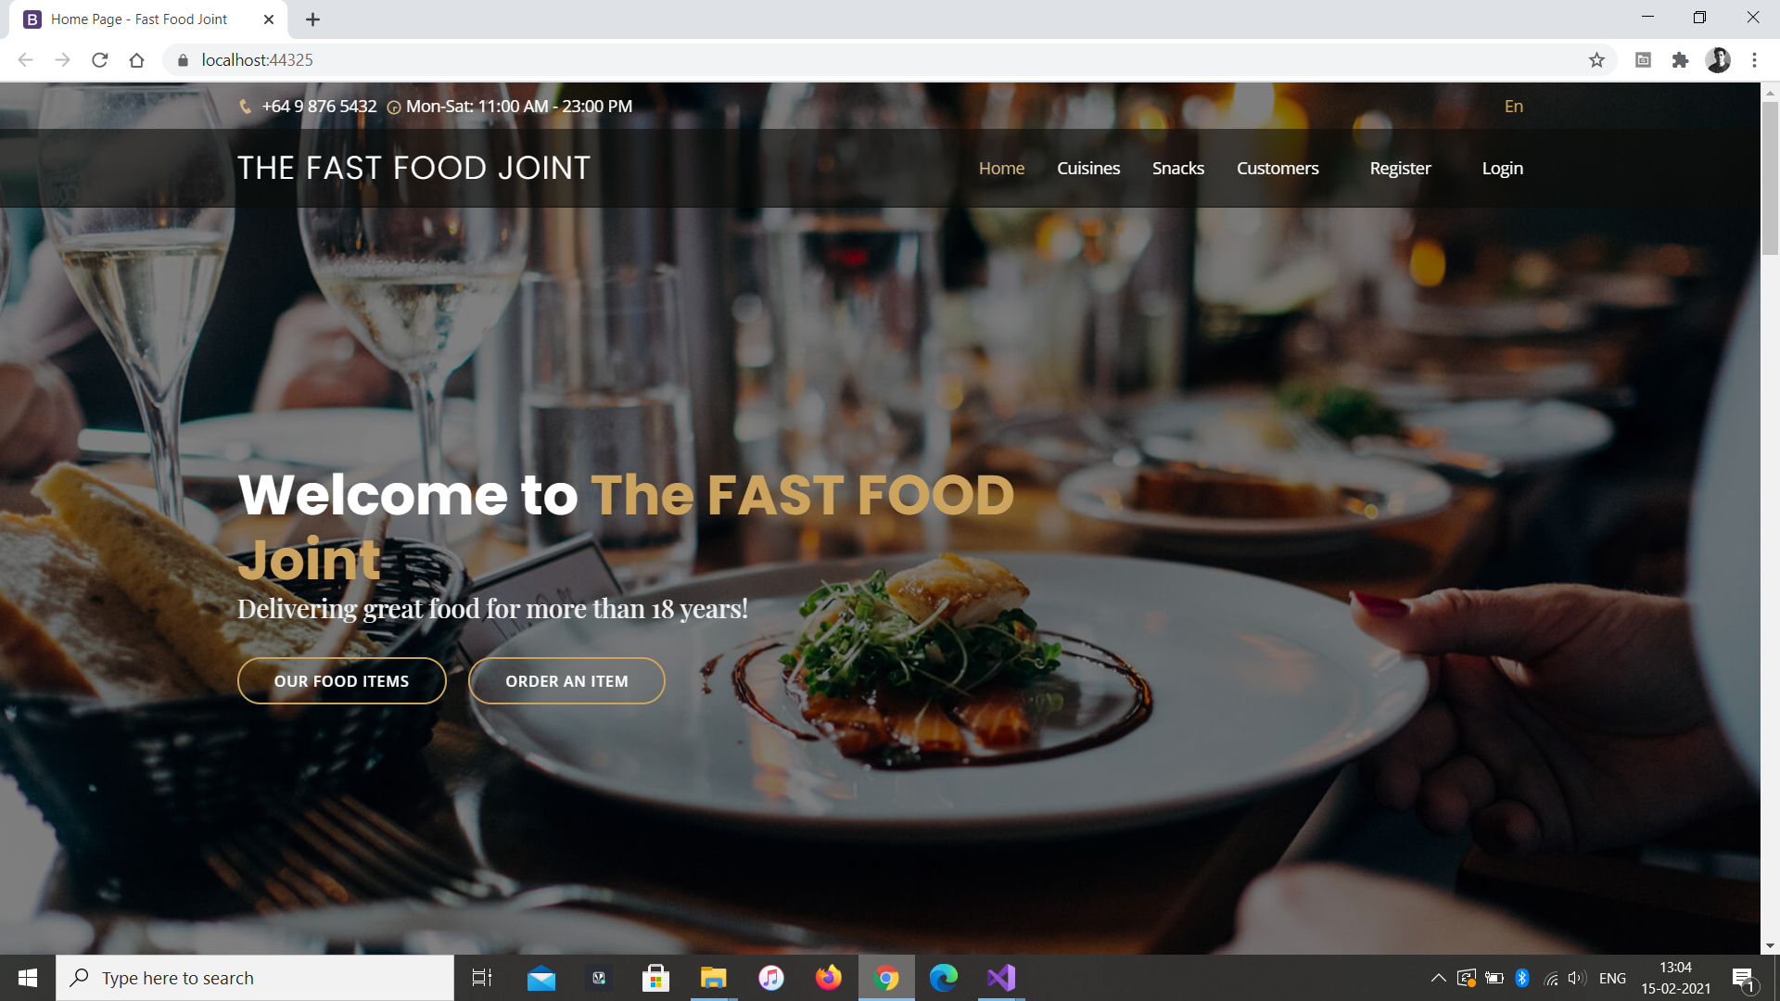

## Cuisines Page

This page of website show the variety of food available on the website.

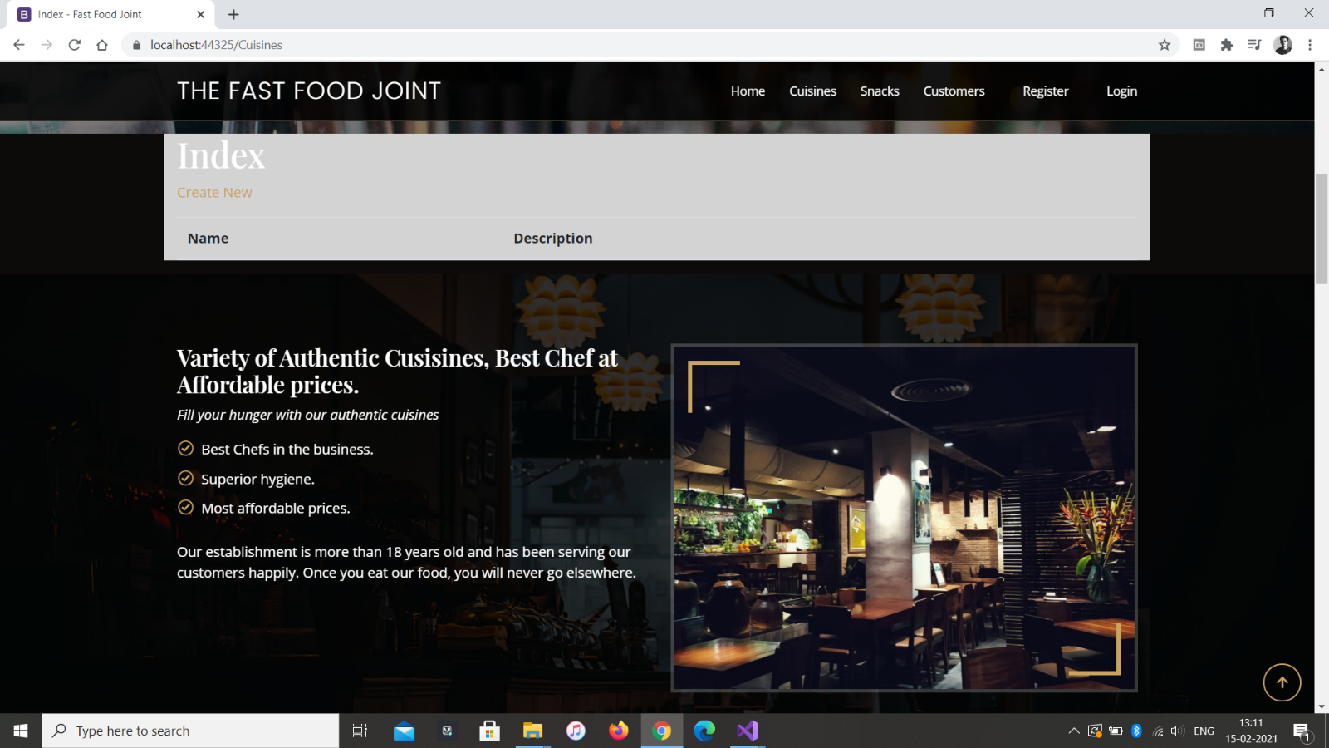

## Snacks Page

This page is show the food items a small amount of food eaten between meals.

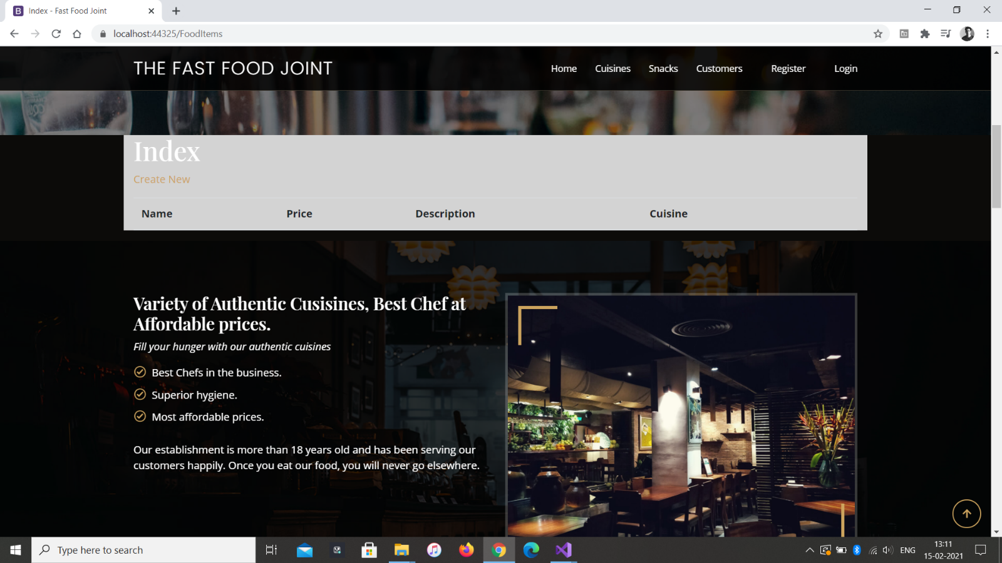

## Customers page

This page provides the data about customers who are registered in this website and admin can observe,delete, and view their details.

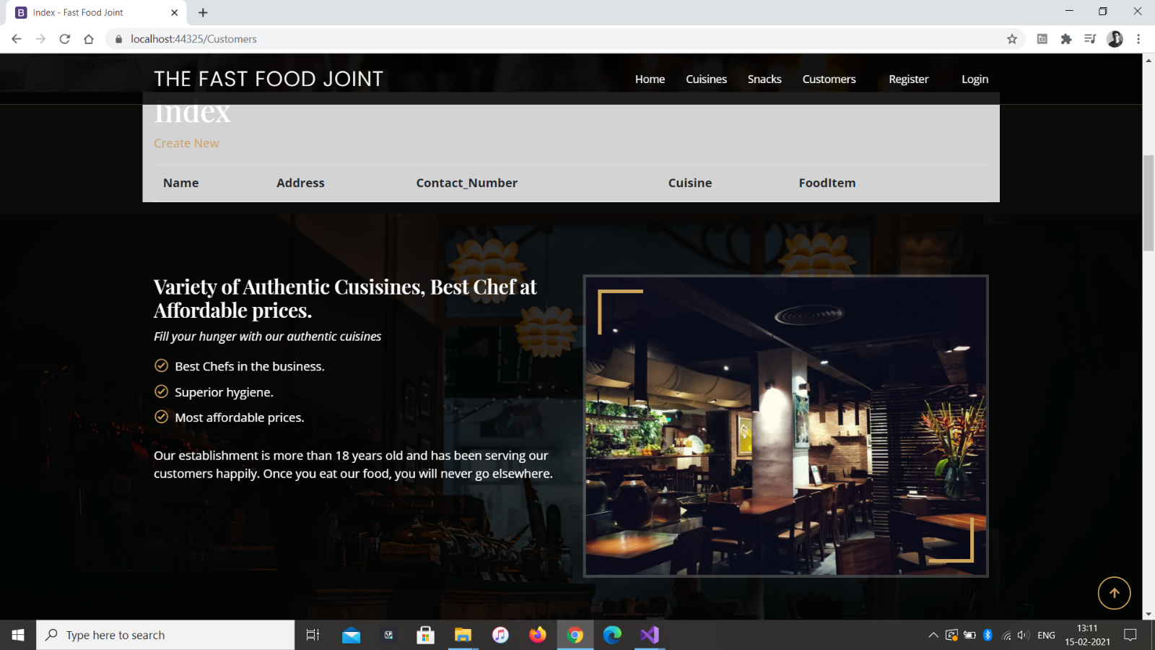

## Register page

In this page user can register their details and login on website.

## 

# Project Testing

|  |  |  |  |  |  |  |  |
| --- | --- | --- | --- | --- | --- | --- | --- |
| Tester –2 | Answer Scale |  |  |  |  |  |  |
| No. | Question | Strongly Disagree (1) | Disagree (2) | Normal (3) | Agree (4) | Strongly Agree(5) |  |
| 1 | I will use the system frequently |  |  |  |  |  |  |
| 2 | Is the system complex? |  |  |  |  |  |  |
| 3 | Is it Easy to use? |  |  |  |  |  |  |
| 4 | I think technical support is required to run the system |  |  |  |  |  |  |
| 5 | I found the various functions in this system were well integrated |  |  |  |  |  |  |
| 6 | I thought there was too much inconsistency in this system |  |  |  |  |  |  |
| 7 | Most people would learn to use this system very quickly |  |  |  |  |  |  |
| 8 | I found the system very bulky to use |  |  |  |  |  |  |
| 9 | I felt very confident using the system |  |  |  |  |  |  |
| 10 | I needed to learn a lot of things before I could get going with this system |  |  |  |  |  |  |
|  |  |  |  |  |  |  |  |

Project testing ,in this project all features of the website are checked and are working properly .This report includes all functionality, testing and navigation bar is tested and worked well. Moreover, testing is done in window 10 ,firefox web browser.

* All testing is completed
* Main functionality is working
* Without any error testing performed

# User Manual

In this project “Fast Food” two types of users are included in this i.e Admin and user. Both have their own responsibility like admin can register,remove ,update and can check the details of food items. Moreover, admin can register a new items as well. Admin can also delete and check the details of customers as well , while users can login into website by having their own credentials and moreover, one can register himself/herself as a new user. User can purchase items very easily.

## User Activities

* User Registration
* Login/Logout
* View food items
* Purchase items
* Confirm order

## Admin Activities

* New Admin registration.
* Login/Logout
* Add, update, delete, check details for the products
* Delete and details Check for customers